Date |  | 05/04/2025 |  |  |  | Date of Report issuance |  |  | 05/04/2025
Time |  | 0443 hrs |  |  |  | Weather |  |  | Clear
Location/Area |  | Road near laboratory |  |  |  | VMECC Personnel Information
Type of  Emergency /  Incident |  |  | FIRE |  |  | SC | Ridzal Aziz
 |  |  | RESCUE |  |  | ASC | Naim
 |  |  | HAZMAT / OIL SPILL |  |  | TRT 1 | Shah
 |  | X | SPECIAL ASSISSTANCE/SERVICES |  |  | TRT 2 | Mizan
Details of Emergency |  | Snake sighted at road near laboratory (Zone 4B) |  |  |  | TRT 3 | Adam
 |  |  |  |  |  | TRT 4 | Rosli
SUMMARY OF EMERGENCY/INCIDENT
VMECC received call via Walkie Talkie from CCR regarding a report from Chargeman that a snake was sighted at road near laboratory. Crew deployed from site to the reported location. Upon arrival, team-initiated assessment and confirmed there was a snake (Non venomous Reticulated Python) at road near laboratory. After donning a PPE, team successfully captured the snake and secured by putting inside the snake bag. Team managed to release the snake outside of VMM premise. Team proceeded with housekeeping and RTB.

CHRONOLOGY OF EVENT
Time | Event/ Action
0443 | VMECC received a call from CCR reporting from Chargeman reporting there is a snake sighted at road near laboratory.
0445 | RIV 02(T1, T3 & T4) deploys to location from station.
0450 | Team arrived location and assess the area.
0452 | Team located the snake at grassy area next to the road.
0455 | Team safely catches the snake; Snake was identified a (Non venomous Reticulated Python).
0502 | The snake was released outside the VMM premises and RTB.

STRENGTHS
- Response time in line with 2025 KPI (1.2 Adherence Response Time) targets.
- Available and operational resources: PPE & Snake catcher equipment and guard
- Special assistance/Service - Wildlife management

RESOURCES, EQUIPMENT & CONSUMABLES MOBILISED
- Rapid Intervention Vehicle (RIV)
- PPE (Snake guard)
- Snake catcher
- Walkie Talkie
IMPROVEMENT OPPURTUNITIES
N/A
PHOTOGRAPH
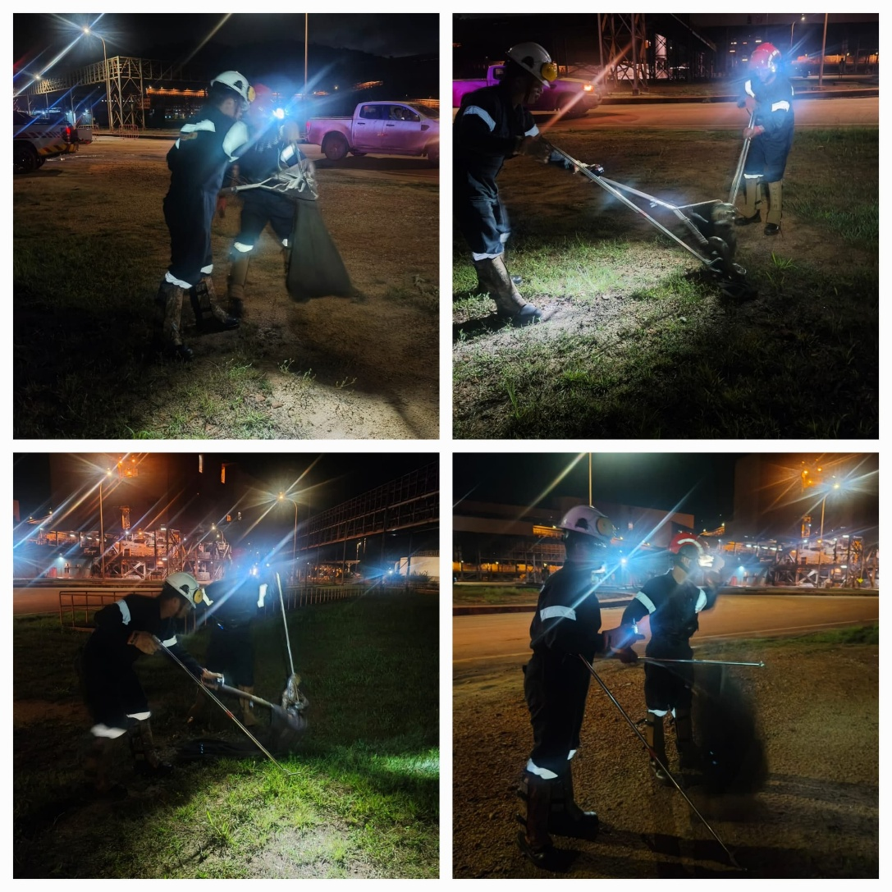
Prepared by: | Naim  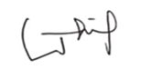  ASC, VMECC |  |  | Reviewed by: | Ridzal Aziz  SC, VMECC   |  |  | Vale Review by:
Date: | 05/04/2025 |  |  | Date: | 05/04/2025 |  |  | Date:

